**AI ROBOT DOCUMENTATION**

Linyun Liu, Jun Park, Jacobus Burger, Josh Boelema

**1.0**

**Overview:**

This is the documentation and introduction for future users or those continuing on this project. This document will give a list of all components used, both hardware and software, as well as any other information deemed necessary to fully understand our project details.

**1.1**

The AI ROBOT is an indoor autonomous robot set to deliver items between various hallways and classrooms. It can be given different goal states based on the user's preference. More specific details will be given below.

**1.2** This project is sponsored by our professor, Dr. Park, who has overseen this project and was done under Parktech.com company.

**1.3 Team members:**

**-Jun Park:** Developer**,** specialized in ros2 middleware

**-Linyun Liu:** Developer**,** specialized in object detection and camera

**-Jacobus Burger:** Developer, specialized in motors and soldering

**-Josh Boelema:** Developer, specialized in construction of physical parts

**1.4** Our robot (working prototype)

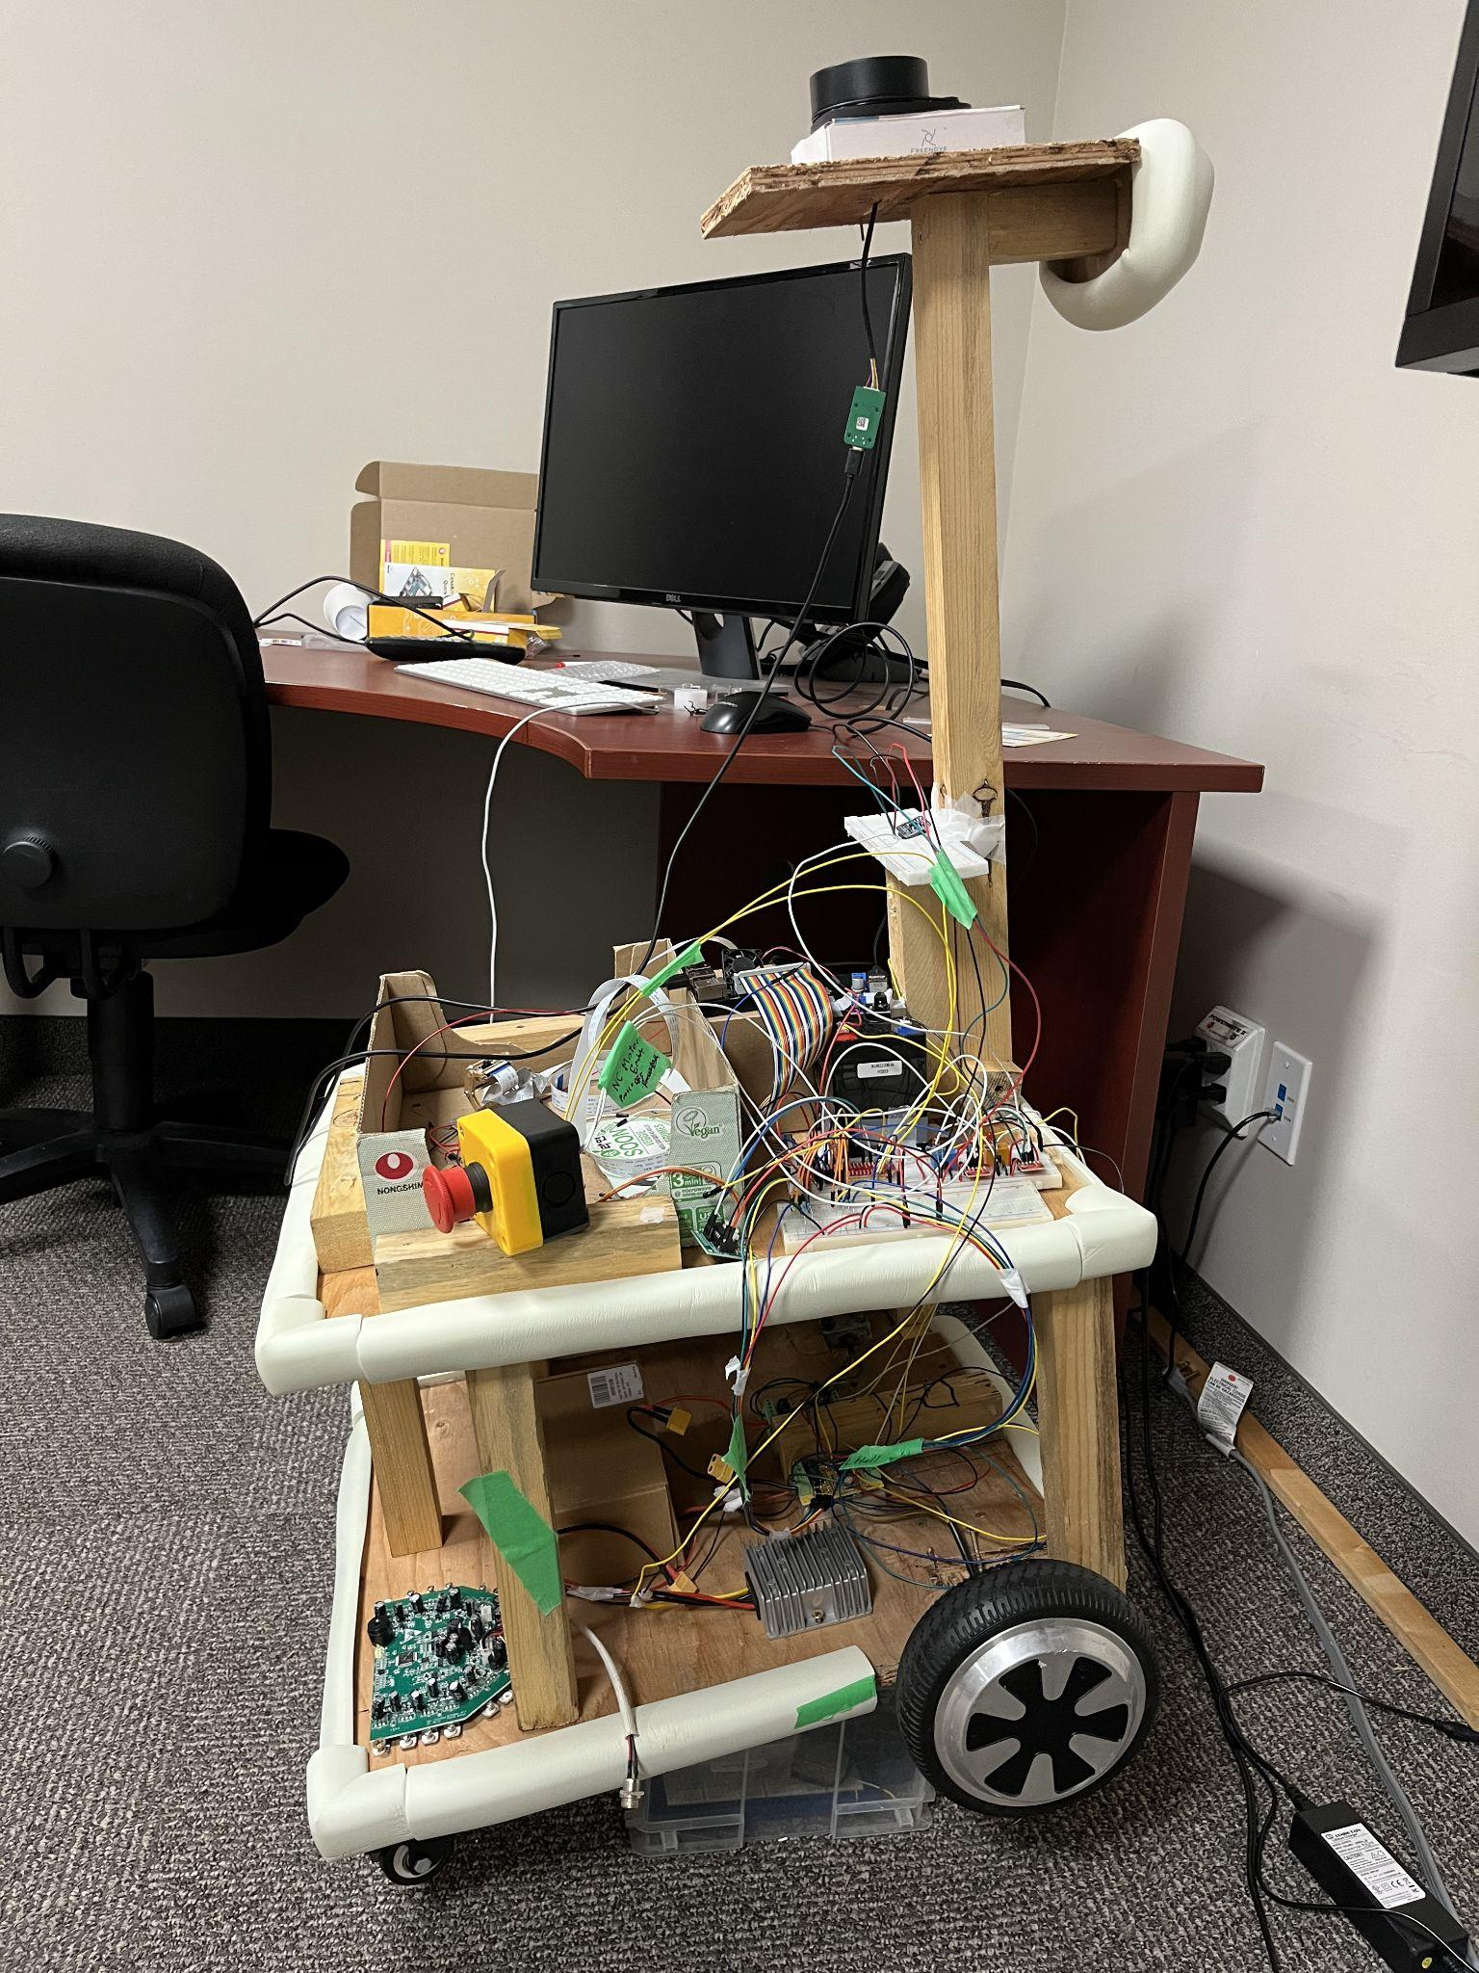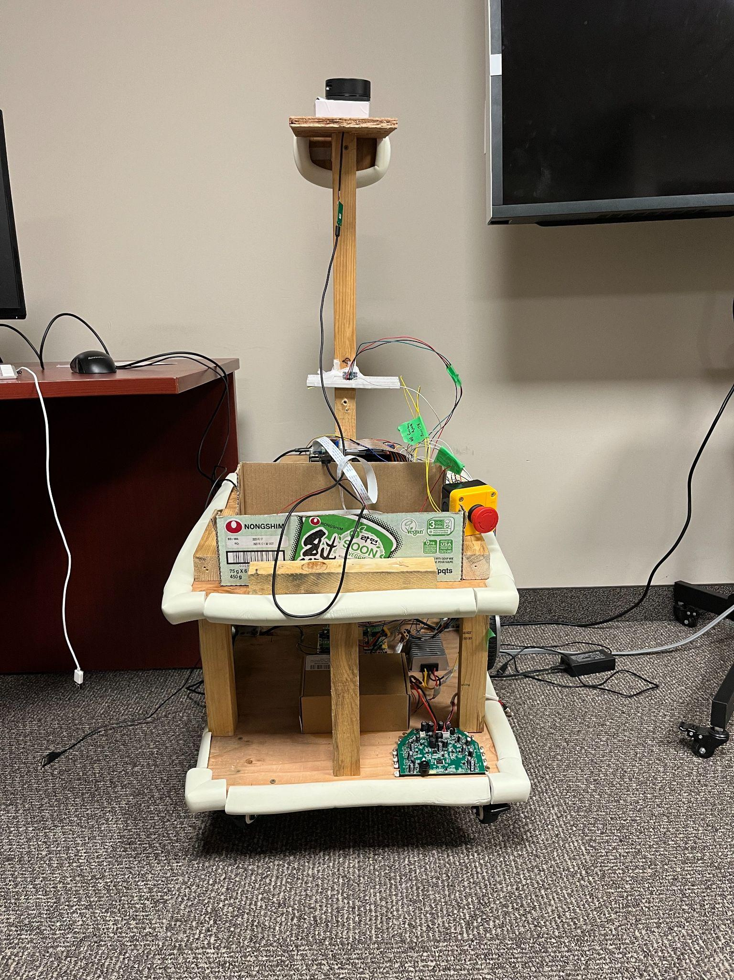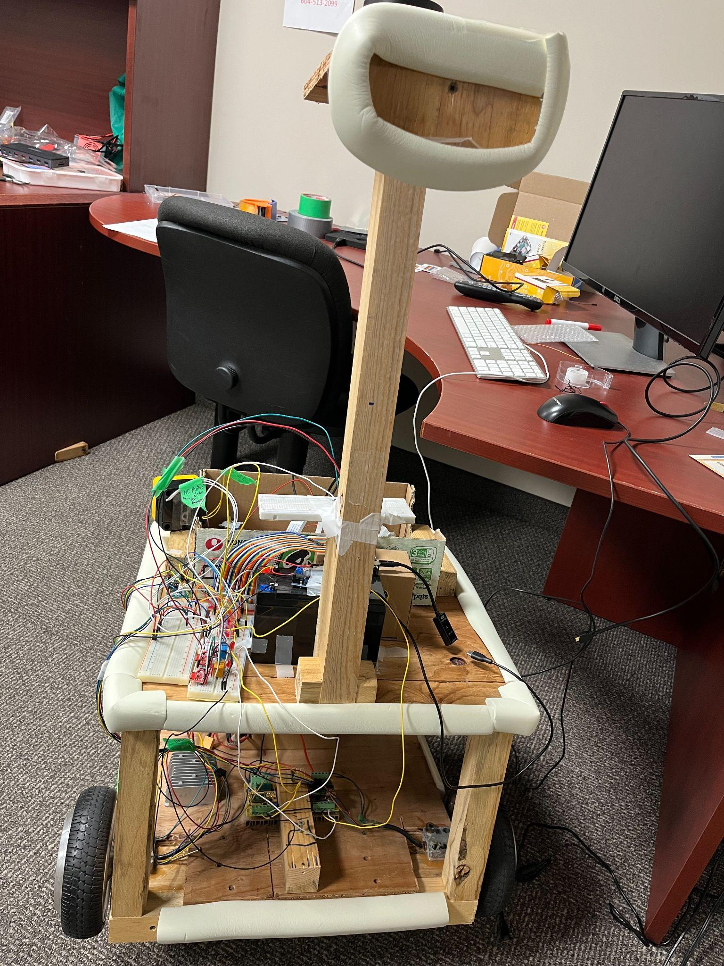

**2.0**

**Hardware components:**

| **No.** | **Parts** | **Description** | **Link** |
| --- | --- | --- | --- |
| 1 | Raspberry Pi | 4th generation 8GB | [amazon](https://www.amazon.ca/CanaKit-Raspberry-Starter-Kit-8GB/dp/B08DHC7KG8/ref=sr_1_2?crid=1I4DLOP72SVX0&dib=eyJ2IjoiMSJ9.Er3kxyNW7MVe6jX6fO_os4_j30uR_FRZM3neZAWKjfz9rbwepgP4QASnURxf9zut0D-y2YZib9UouZS_BGFV0Zz-oO93FWw698ieV7NJ44nr96ITdV3V4NR85lYHFJfALIhjGnjcbUtzAF3fDPfFNeBTQIBVvTYSu5tZgByZNjUWmxjp8RuIv-wU7-DfbHoe1A9ilVitBhq6rbHEXePWF-tzp-tDTg2Rf1K4QOWiCxSFjLDzgS3UbzMcwn9oaL4lSDAw3sC0E7qb2P6CmYKKgsEJKnAzn8PvV8_s3OMfAAA.OH21ZBO0yw3lsdUOJTclQvgl6I4Y3I-ME6nSxrzfFAo&dib_tag=se&keywords=raspberry%2Bpi%2B4%2BB%2B8GB%2Bcanakit&qid=1720821522&sprefix=raspberry%2Bpi%2B4%2Bb%2B8gb%2Bcanaki%2Caps%2C157&sr=8-2&th=1) |
| 2 | Hoverboard Motor | DC brushless motor (standard hoverboard motor) | [AliExpress](https://www.aliexpress.com/i/2251832760398486.html?gatewayAdapt=4itemAdapt) |
| 3 | Motor Controller | ioRand 300W 5-50V PWM DC Brushless Electric Motor Controller | [amazon](https://www.amazon.ca/RioRand-Brushless-Hallless-Electric-Controller/dp/B087M3GVYX/ref=sr_1_4_sspa?crid=14C8P36DNBYDP&dib=eyJ2IjoiMSJ9.rYa20uLTFexQYIr-Lj7kl0vlflpkTzn50SsSu5uZpkB8RYyogN3m9TloQNaE9ZHByjYhJCGYbGrgXowg5xbpUnDM2LXFIsGx_6_bQ0Z0aF23vNeEMhQtQMhtX5E_I0Mo-SnVYMWimhmM6bjkmTWIVpjvIX2u1DnW-nS_H07sEeh6y9egTqXmq_jMDlQc1tWNT4RhmRBvtLp8pKq4ib45fTf8vCsUUSrWuU_oWQmltKC8xNElXtFSBnvfCm9B2Z0nD1lGGAB8HXChEaRDTam29zXkwt94bo4G6eu6uB1ExZ0.Rtnrjc8AKnfmwU3_iJ4N2xYZaIcspYK3SDSFNgUfnjU&dib_tag=se&keywords=brushless%2Bmotor%2Bcontroller&qid=1718235038&sprefix=brushless%2Bmotor%2B%2Caps%2C199&sr=8-4-spons&sp_csd=d2lkZ2V0TmFtZT1zcF9hdGY&th=1) |
| 4 | Lidar | RPLIDAR A1M8 | [amazon](https://www.amazon.com/Slamtec-RPLIDAR-Scanning-Avoidance-Navigation/dp/B07TJW5SXF/ref=sr_1_2?keywords=slamtec+lidar&qid=1657681907&sprefix=slamtec%2Caps%2C98&sr=8-2) |
| 5 | IMU | BNO055 | [Amazon](https://www.amazon.ca/Adafruit-Absolute-Orientation-Fusion-Breakout/dp/B017PEIGIG/ref=pd_ci_mcx_mh_mcx_views_0?pd_rd_w=4ie8i&content-id=amzn1.sym.d89e4a4e-5696-4c12-9830-260f358f425a:amzn1.symc.40e6a10e-cbc4-4fa5-81e3-4435ff64d03b&pf_rd_p=d89e4a4e-5696-4c12-9830-260f358f425a&pf_rd_r=AXEK9WNYV47K6QFV9647&pd_rd_wg=DWuFf&pd_rd_r=0271ef90-03cf-4ced-a6ae-542d8a3a7236&pd_rd_i=B017PEIGIG) |
| 6 | DAC | Teyleten Robot MCP4725 12-bit I2C | [Amazon](https://www.amazon.ca/Teyleten-Robot-Breakout-Development-Raspberry/dp/B0BWTX88JL/ref=sr_1_4?crid=171SL9SWL9HQR&dib=eyJ2IjoiMSJ9.ImU7HQxF9ksRmAwOXdVDeBvHDsXKVZYzM1uvUWyU2eHBpLpNrRVfoe7JPvDpdpdVBy3uWjRvhpVRpkjkKzhHVhdYyVUPVC7iF82R_apIKsU8fh2UiuboMNwEZlj8459-jz3dQR7Gt6FaX1dVoaMG-3Ls4TYPlrYD7c-MmSXo-kdyice0yCPIFrVP55IoP7UfIebeAx2Ekny59F0-Rt0OrmHtTxjrjZ5qxineKjHaUT9K3CAQca58mhH5xTR5v5yQUlx9AGi_y4vfRtH3b6b4hawyUaIsZ6wZQWel1_qgp3I.Nd5FbitoK8VNDg60PW22-o26V3yGrdWl361J4iYiQlo&dib_tag=se&keywords=MCP4725&qid=1719003014&sprefix=mcp4725%2Caps%2C152&sr=8-4) |
| 7 | Stop button | Baomain Red Sign Emergency Stop | [Amazon](https://www.amazon.ca/Baomain-Emergency-Button-Weatherproof-Pushbutton/dp/B00NTT91Y0/ref=pd_day0_d_sccl_3_3/141-8270664-9911469?pd_rd_w=U7V7M&content-id=amzn1.sym.a0f07c06-3bfe-427e-9527-5be8cea27b66&pf_rd_p=a0f07c06-3bfe-427e-9527-5be8cea27b66&pf_rd_r=KFWDJAX9CDV9FKGVR00Z&pd_rd_wg=skF04&pd_rd_r=28aa22d0-6608-4209-b117-0473a23b1fe1&pd_rd_i=B00NTT91Y0&psc=1) |
| 8 | 12 V battery & 36 V battery | NASTIMA 12V 8Ah Rechargeable Lithium Iron Phosphate Battery & Hoverboard Motor Battery | [Amazon](https://www.amazon.ca/NASTIMA-Rechargeable-Phosphate-Scooters-Fishfinder/dp/B0B5WBHDDN/ref=sr_1_6?crid=2RDRA6ID3JJ7U&dib=eyJ2IjoiMSJ9.e2MI3ho8RhshoT2xJamrhE3x-ETi_3gHLIvpi2__nyyTfMmzTqohNbI8X3xnfpD25r6_3g-1Pgcuz6rOS3AZMrNk6btjsW3xmUsYOorY-JUw7KZVg9I8wZnbwOKb43gnyzK87HQENPGQe0zhixCKPoZnuwaqWvU-RWTgkO9oyY89xkFHhU3RSHhJYpV5kQnWPfnzAZugetWrz8vOjFQN7QZZy_I7zxIaiQHEpuo3wKT7sa1GOn8_D7WNCu5KwwtrdiSfrqX-TalIoTXbeXYUaFXmqX-Khvcmg1gZbItb_Qs.5xYenCdAWmZR3dGR_gSTeaDXKsKBQ9j8ggTkSZg256U&dib_tag=se&keywords=lifepo4%2B12v%2B8ah&qid=1717701859&sprefix=lifepo4%2B12v%2B8ah%2Caps%2C165&sr=8-6&th=1) |
| 9 | DC/DC converters | 12V to 5.2V 6A (PI) and 36v ~ 12v Step Up/Down | [12-5 Amazon](https://www.amazon.ca/DAOKAI-Converter-Voltage-Regulator-Charging/dp/B09YYG4Y5Z/ref=sr_1_6?crid=7EI9KWHPGF8N&dib=eyJ2IjoiMSJ9.4ihkAs2HDil07Y5qYU_8M8wu-k60CYWjt1N1e7cMQbVmyTQ-iQyrSPj8lM630ACl4OaroqxfYD_RkIq0lmeF7Q8aIKFuYEwXxEJrzPaNruWJ-D5zDXnzSF8mfIjkGmjdv-bPkq18A1pPM7gW-O4XpzUaDty-wbJeoMdn_xLJN6gGTwnhGe-Zw46Sc7IMHfGYQJj_FJZ4fvnmMi6T4u9o9XEJdu1aN5-dV2OvFZZCHjQF8vufVbQz-HJPAoGlgsKtQFiCknXfuMGr27y35Lr-fCqE6KAMVtujSMOOqhug8KY.fv4TmzAHkjDYX5YuV9JP8LAW62imniYEhqbe-axbsDM&dib_tag=se&keywords=12v+to+5.1v+5a+converter+usb&qid=1717693770&sprefix=12v+to+5+1v+5a+converter+usb%2Caps%2C135&sr=8-6)  [36-12 Amazon](https://www.amazon.ca/DROK-Waterproof-Automatic-Regulator-Stabilizer/dp/B018WZK5XQ/ref=sr_1_11?crid=1RKPI5I2OMZQH&dib=eyJ2IjoiMSJ9.g6auky3fdxYSopUoIO67t0uExf0VOY3aBjUokOFIx8gq9ZScHVUnR757piYgqws6sIIpPRv3UsCmS3xczYKvF7rnCYuxwvVZUKJLHvHolxFpw2mJDkR0zLTZ4lVzTbxVxWYq_o1Y0AGTnHXYk41_GzjkXLWxC-6LNXcCfyhH8uOrxFxoFaRXaOBBvoOFmdMGzqN3ZydRXo9U8f1BJoEQmgWCplsyT_wuYWW9aL77wanXdUYB5eEUd2VRmHwuG0mmXS2ydz_-zgt3aSveQP0VYT572je_P8sz2aDKH-q_nHg.fjpLlSuzemNcDtB2YvItt1lBAaUnIZKFyaJa5yQDxGQ&dib_tag=se&keywords=36v+to+12v+converter+up+down+converter&qid=1719425651&sprefix=36v+to+12v+converter+up+down+converte%2Caps%2C122&sr=8-11) |

**2.2**

**Description of Hardware Components:**

| 1. **Raspberry PI4** | Our central component for controlling the programming of the various hardware parts. Uses Ubuntu 20.04, not raspbian OS. |  |
| --- | --- | --- |
| 1. **Hoverboard Motor** | The standard 6.5 inch hoverboard motor used in almost every model. Has 14 poles however, not the standard 15 or 30. |  |
| 1. **Motor controller x2** | This is to allow us to control the speed, stop, and start, and separately control the motors in a programmable way. |  |
| 1. **Lidar** | Primary use of the lidar is for object avoidance and mapping of the indoor environment. Furthermore, the lidar will be used for odometry data to give us a more accurate position of the robot. |  |
| 1. **IMU** | **r**eports acceleration, orientation, angular rates, and other gravitational force. Allows us to use that information to get the direction of our robot and other data used for odometry purposes. |  |
| 1. **DAC x2** | generate variable voltage inputs directly from the Raspberry Pi's digital outputs, allowing for controlling motor drivers that rely on analog signals to adjust behavior. |  |
| 1. **Stop button** | A simple emergency stop button that when pressed deactivates the motors and when it is turned back the motors are reactivated but will not run again until programmed to do so. |  |
| 1. **12 V battery** | Our main battery source to keep all of the components charged. This includes the RPI, the motors, the motor controllers. |  |
| **8. 36 V battery** | The battery from the hoverboard that is used to give power to the motors. |  |
| 1. **DC/DC converter** | Converts from 12V to 5.2V 6A and is used for the 12 v battery to the raspberry pi4. |  |
| **9. DC/DC converter** | Converts from 36v↔12v and is used for the battery to charge the 36 v battery that is used for the motors. |  |

**2.3**

| **Additional Components** | **Purpose** |
| --- | --- |
| Relays x2 | For the stop button |
| Jumpers | Connections for various components |
| Resistors | For LED’s, transistors, ect. |
| LEDs | For letting us know when motors are on or off |

**3.0 System Architecture (Jacobus):**

**3.1 General Circuit Diagram of whole system:**

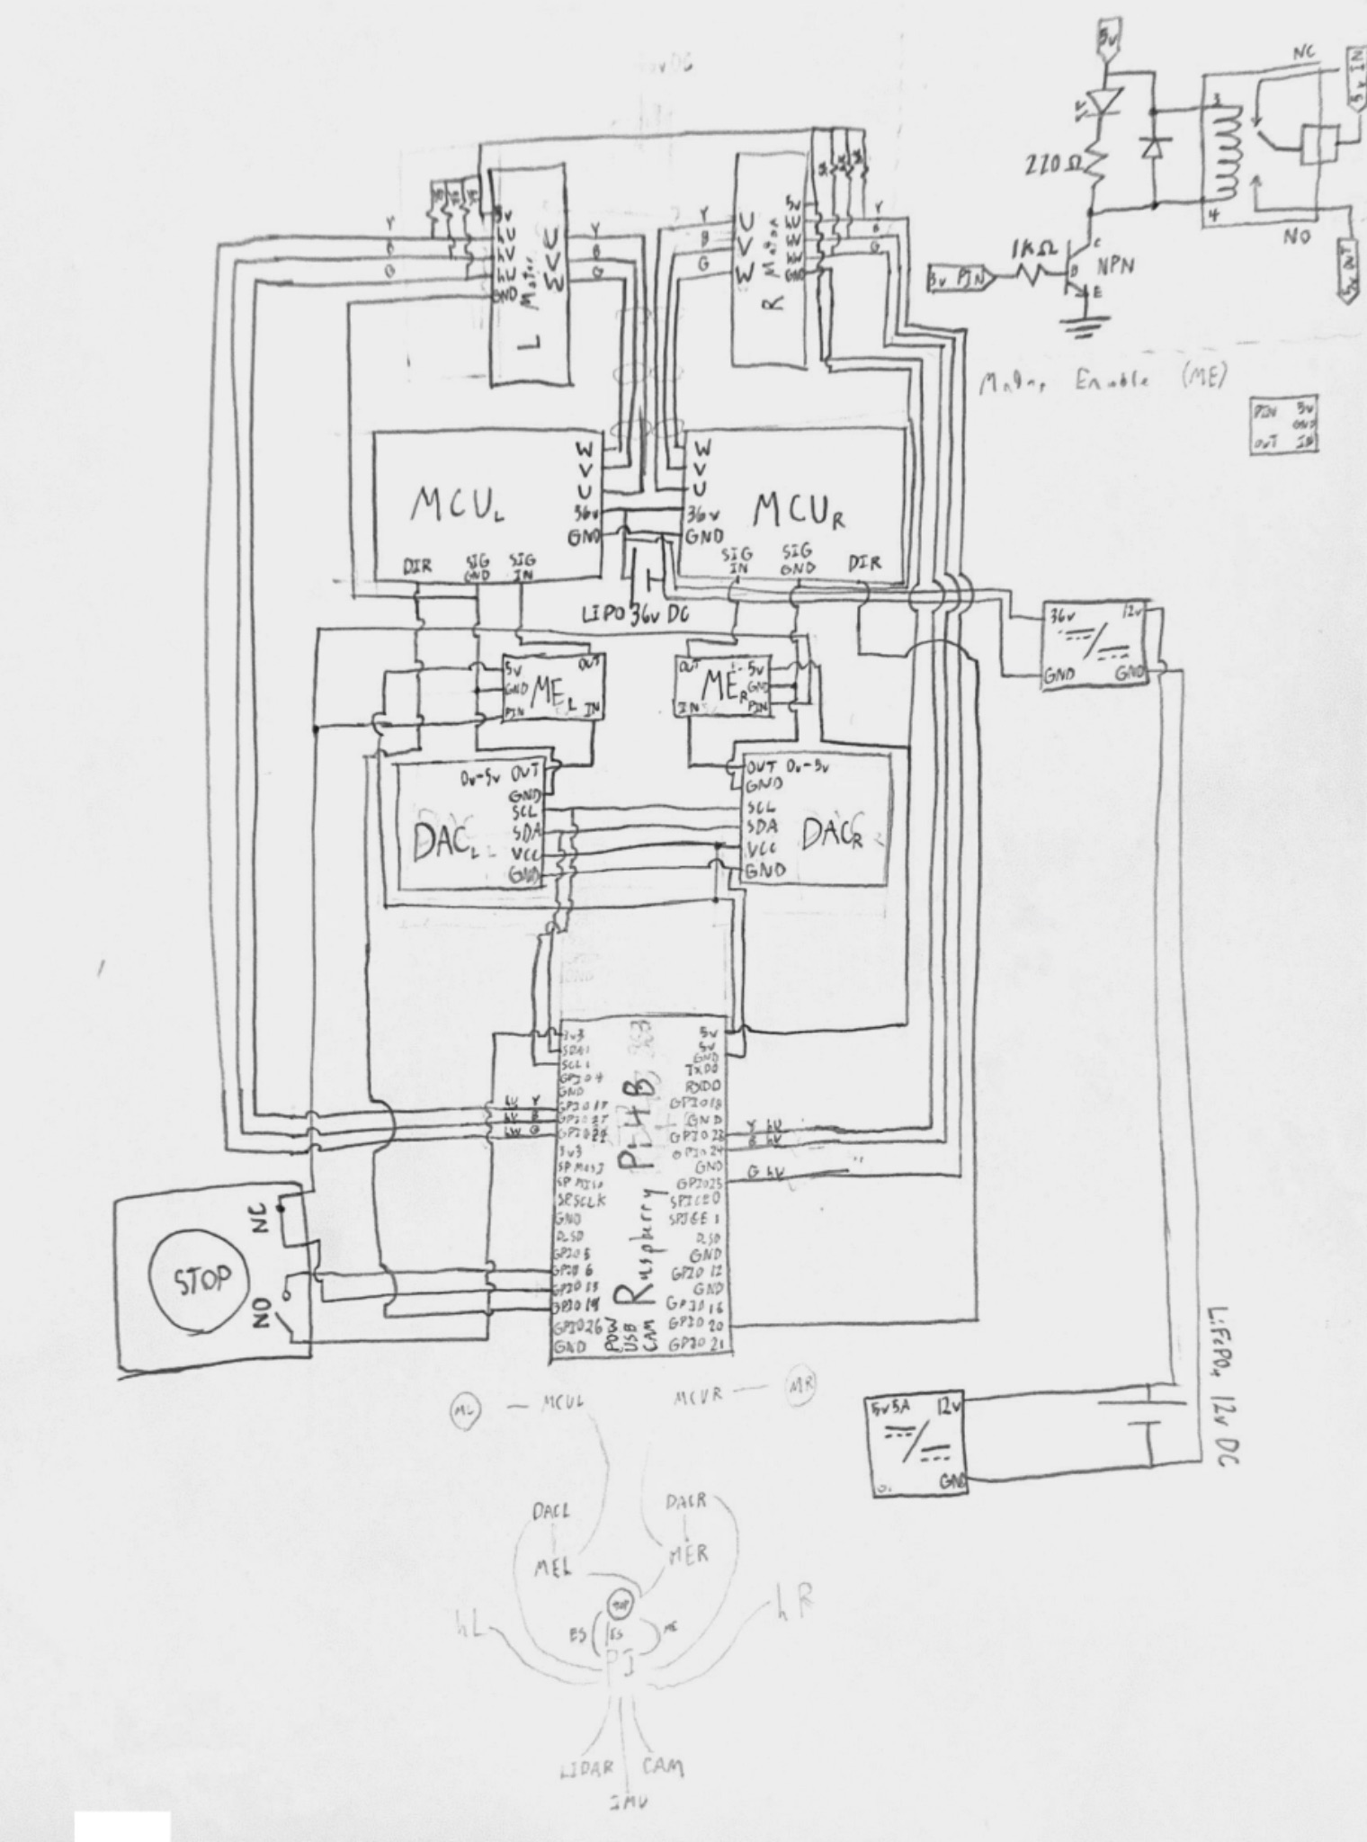

**3.2 Circuit Diagram of General Hardware Components:**

**3.3 Circuit Diagram of General Software Components:**

### **4. Software Documentation**

* **ROS2 Configuration: Detail the ROS2 setup, including installation steps, configuration files (e.g., launch files, parameter files), and package dependencies.**
* **Nav2 Configuration: Document the configuration of Nav2, including path planning, localization, and obstacle avoidance settings.**
* **Custom Nodes and Scripts: Explain any custom ROS2 nodes, scripts, or algorithms developed for the project. Include code snippets, explanations, and flowcharts if applicable.**
* **Integration: Describe how the different software components are integrated and how they interact with the hardware.**

### **5. Navigation and Control**

* **Localization: Explain the methods used for localization (e.g., SLAM, AMCL) and how the robot determines its position within the building.**
* **Path Planning: Document the path planning algorithm, how paths are generated, and how the robot follows them.**
* **Obstacle Avoidance: Describe the strategies used for obstacle detection and avoidance using LIDAR, camera, and other sensors.**
* **Motor Control: Explain how the hoverboard motors are controlled, including the use of IMU data for stabilization.**

### **6. Testing and Calibration**

* **Testing Procedures: Detail the tests conducted to verify the functionality of different components (e.g., motor testing, sensor calibration, navigation testing).**
* **Calibration: Document the calibration procedures for sensors like LIDAR, IMU, and camera.**
* **Performance Metrics: Include any performance metrics, such as navigation accuracy, speed, battery life, etc.**

### **7.0 Troubleshooting**

**7.1 Major Issues:**

**7.2 Error Logs: Include descriptions of error messages and how to resolve them.**

### **8.0 Appendices:**

**8.1 Code Repository:** [**GitHub Link**](https://github.com/)

**8.2 References:**

**ROS2 humble:** [**https://docs.ros.org/en/humble/index.html**](https://docs.ros.org/en/humble/index.html)

**Nav2:** [**https://nav2.org/**](https://nav2.org/)

**Slam_Toolbox:** [**https://wiki.ros.org/slam_toolbox**](https://wiki.ros.org/slam_toolbox)

**RPLidar ROS:** [**https://index.ros.org/p/rplidar_ros/**](https://index.ros.org/p/rplidar_ros/)

**Yolov8:** [**https://index.ros.org/p/rplidar_ros/**](https://index.ros.org/p/rplidar_ros/)

**8.3: Literature Review:**

Automaticaddison, A. (2021, April 13). *How to build an indoor map using ROS and LIDAR-based SLAM – automatic addison*. https://automaticaddison.com/how-to-build-an-indoor-map-using-ros-and-lidar-based-slam/

Belkin, I., Abramenko, A., & Yudin, D. (2021). Real-Time LIDAR-based localization of mobile ground robot. *Procedia Computer Science*, *186*, 440–448. https://doi.org/10.1016/j.procs.2021.04.164

*Hello from Articulated Robotics | Articulated Robotics*. (n.d.). https://articulatedrobotics.xyz/

Instructables. (2023, September 6). *Robust robotic platform from old hoverboards and used metal*. Instructables. https://www.instructables.com/Robust-Robotic-Platform-From-Old-Hoverboards-and-U/

Liu, H., Wu, C., & Wang, H. (2023). Real time object detection using LiDAR and camera fusion for autonomous driving. *Scientific Reports*, *13*(1). https://doi.org/10.1038/s41598-023-35170-z

Malik, S. (2023, May 4). *LiDAr SLAM: The Ultimate Guide to Simultaneous Localization and Mapping*. Wevolver. https://www.wevolver.com/article/lidar-slam

Rivai, M., Hutabarat, D., & Nafis, Z. M. J. (2020). 2D mapping using omni-directional mobile robot equipped with LiDAR. *TELKOMNIKA (Telecommunication Computing Electronics and Control)*, *18*(3), 1467. https://doi.org/10.12928/telkomnika.v18i3.14872

RoboFoundry. (2022, September 11). Building a robot using Hoverboard — Part1 - RoboFoundry - Medium. *Medium*. https://robofoundry.medium.com/building-a-robot-using-hoverboard-part1-26e1b20b2b28

Staple, D. (2021). *Learn Robotics Programming - Second edition: Build and Control AI-Enabled Autonomous Robots Using the Raspberry Pi and Python*. Packt Publishing.

**9.0** **Concluding thoughts:**

In the future we, or whoever takes over this project, hope that it will be turned into a Neufeld Science Center tour robot that will be able to navigate through the whole building. We hope it will have a microphone and screen that says and displays messages that help students see where they are in the building and provide facts and other useful resources.

### **9.1 Conclusion:**

In the end, we were able to get our robot to autonomously move through the hallway and therefore be able to deliver items like tea, or books to other professors in the building. We had to change our original goal which was to deliver books from Dr. Parks office to the library but there was a lot of difficulty navigating outside due to rocky roads and difficulty mapping the outside. Furthermore, our robot is currently limited to one floor as our elevator button presser idea had to be postponed due to the project coming to the end and not having enough time. Also, there is further work needed to be done with the jump that initially occurs when the motors begin moving and the drifting problem that is occurring in RVIZ2 because of our odometry data is not yet perfect.

**9.2 Acknowledgments:**

We would like to thank Dr. Park for initiating this project, providing the funding for all the materials, and for the various meals generously given to us. We would also like to thank Trinity Western University for allowing us to use their office in the Science Center.